# Trace Report BuG 1 – Abhimanyu bhat – 11732514- ass 4

## Tracing – Incorrect calculation of fines

1. Portion of the code where the failure occurred.

Explanation: This is seen in the **bookScanned** method in **ReturnBookControl** class. We know this because the overdue fine has been incorrectly displayed as $0.00 and it should have been $1.00.

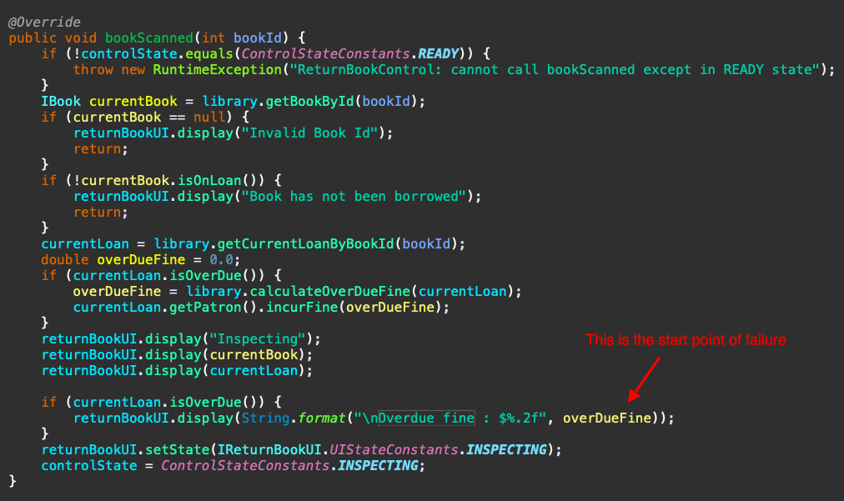

2. The above failure is called in the **Main** class in the **returnBook** method.

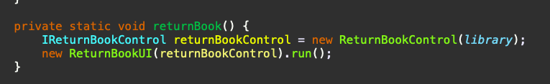

3. I added breakpoints to several methods in the stack trace to check if that method was being called.

Breakpoints added were in **getDaysDifference** in Calendar class, **calculateOverDueFine** in Library class and **bookScanned** in Main class.

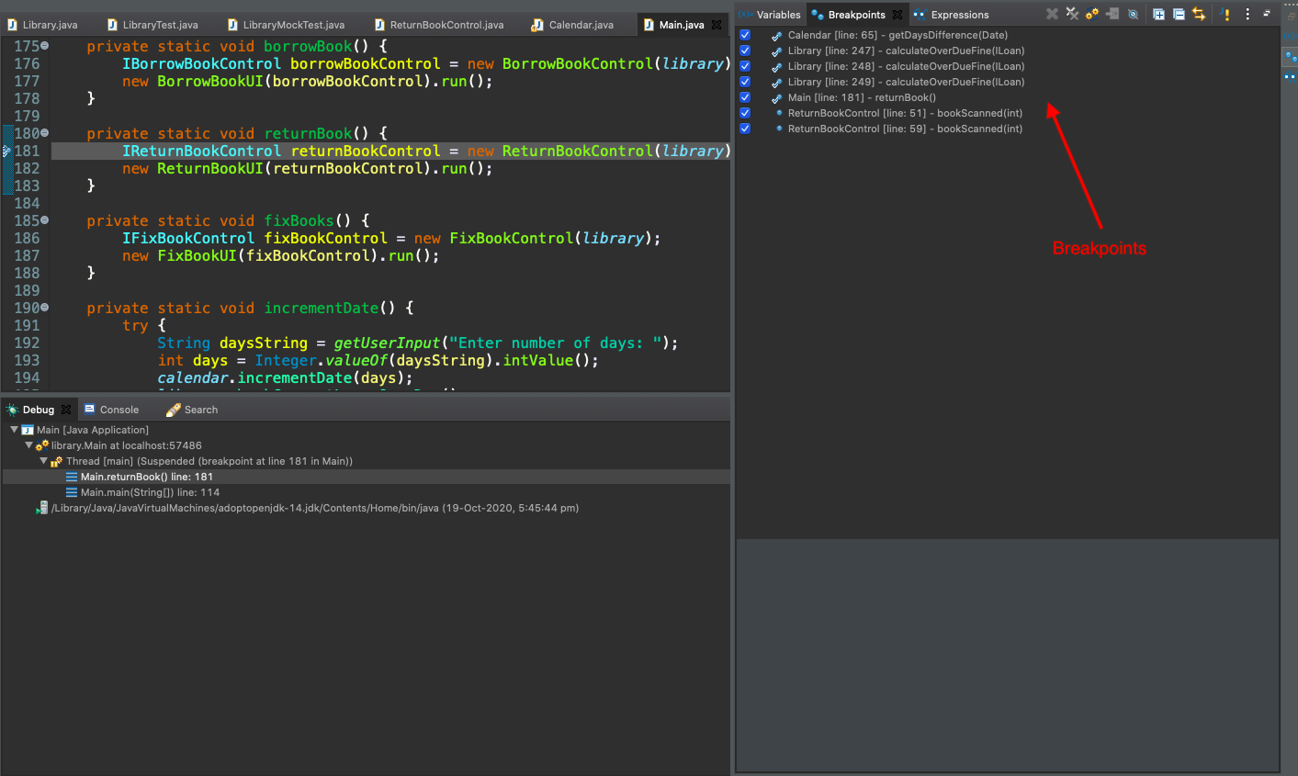

4. I then stepped through each of the breakpoints in **debugging** mode. These steps are shown as below.

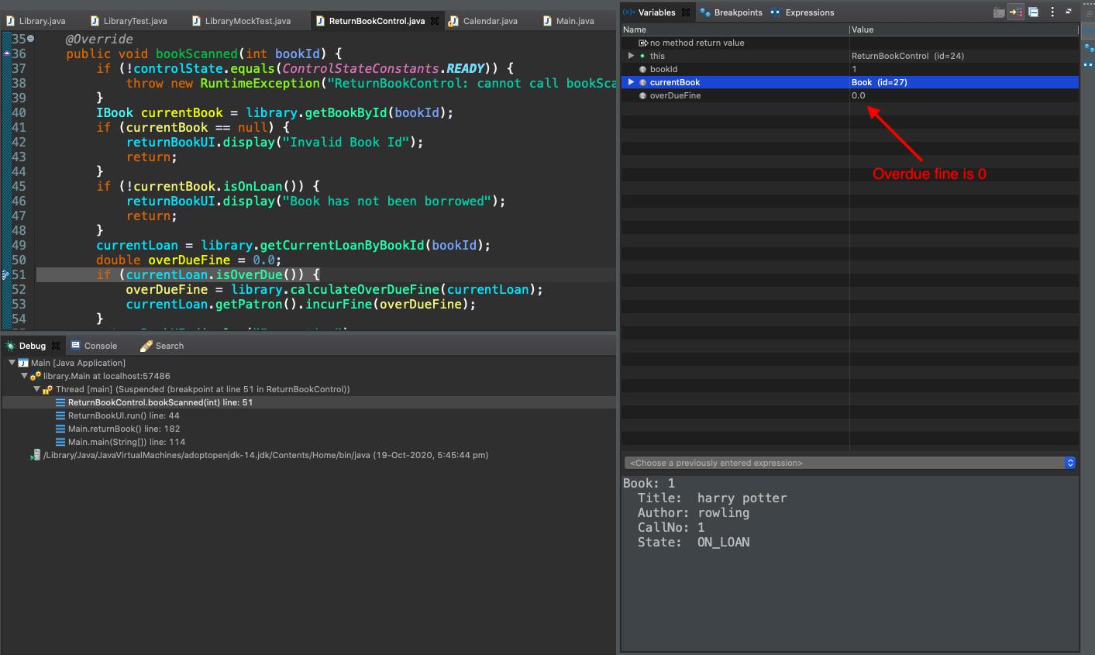

5. The next step is the dueDate. The screenshot shows dueDate is 22nd October 2020.

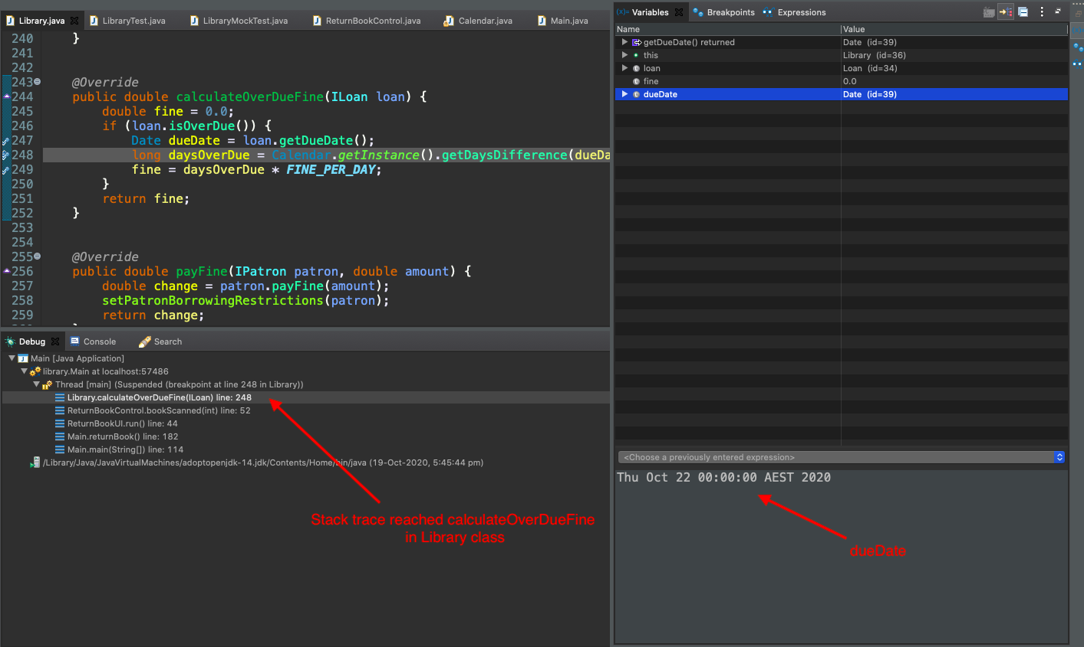

6. This screenshot shows the incorrect calculation of difference in days in the **getDaysDifference** method of Calendar class. The difference is shown as 0 when it should have been 1. This is because current date is 23rd October 2020 and target date is 22nd October 2020.

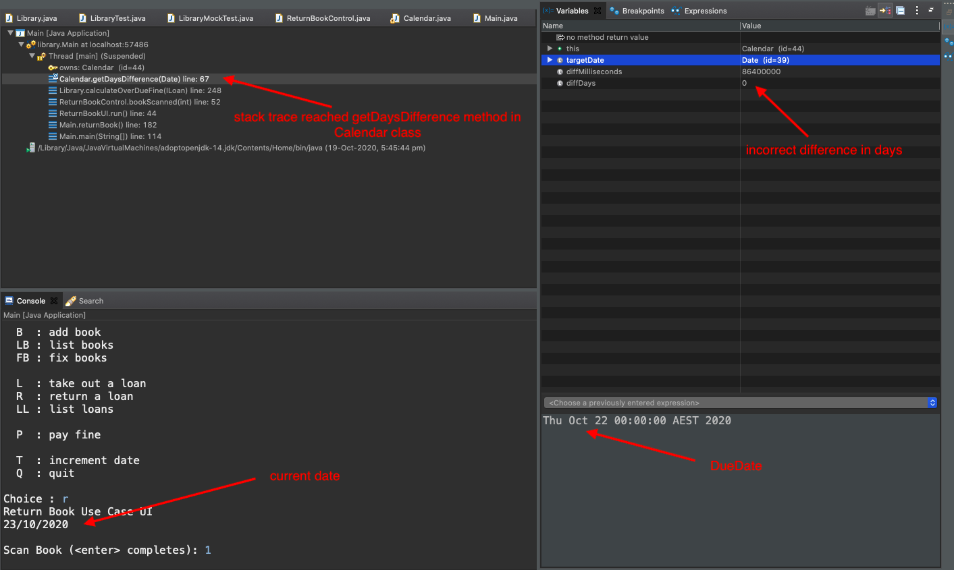

7. This screenshot shows the incorrect fine calculated.

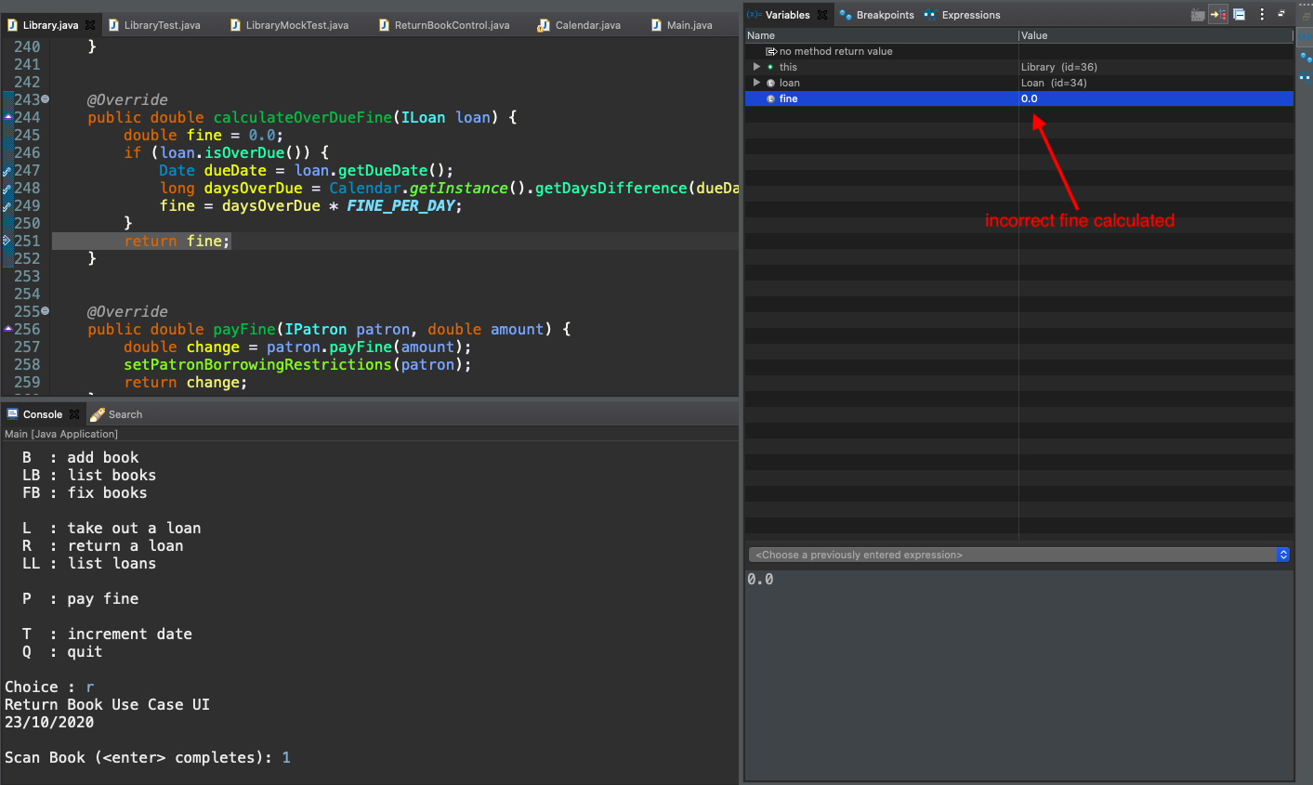

8. The below shows overdue fine displayed.

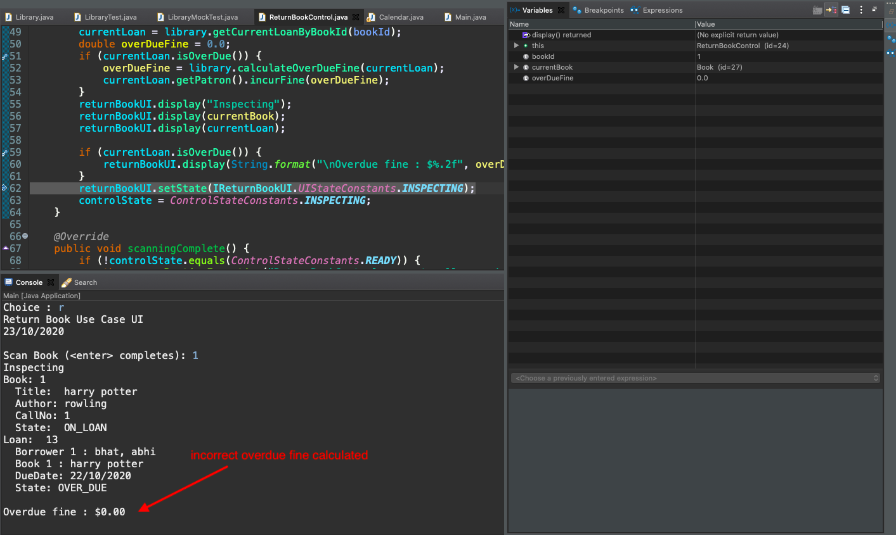

9. Hypotheses

My hypothesis is that if the days calculated are incorrect then the fine amount calculated will also be incorrect. I try to investigate if the value of the constant MILLIS_PER_DAY is correct. Below screenshot shows the variable.

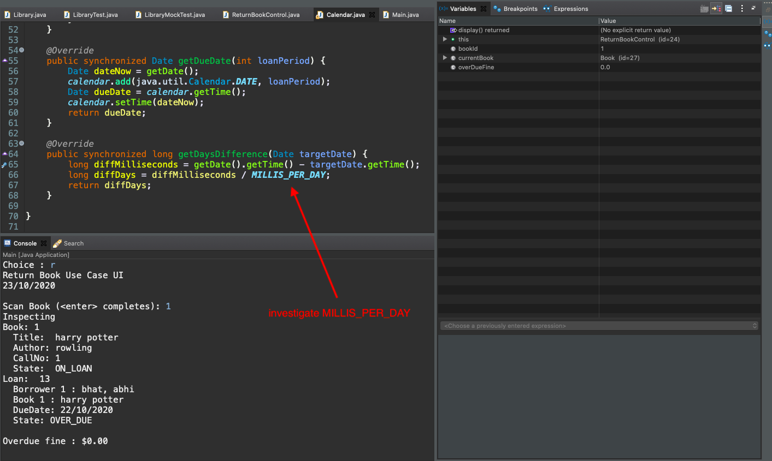

On investigation, it looks like the value for MILLIS_PER_DAY is double the actual value. It should be 8.64e+7 but it is 17.28e+7 instead. The screenshot below shows the same.

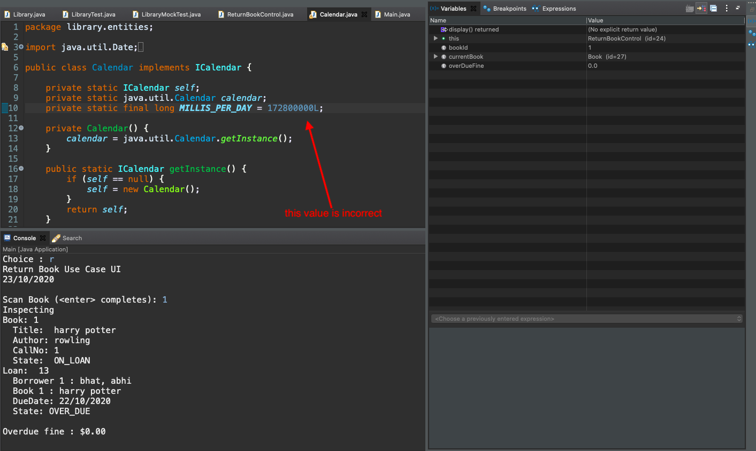

10. Solution

I changed the value of MILLIS_PER_DAY to the correct value and then the fine was being correctly calculated. Screenshot below shows the correct fine amount.

